Vendor Management System

This project consists of 3 users

1. Admin: admin can login to application and then can all fruits/vegetables, user and vendor details
2. Vendor/Framer: this user can signup and login to application and after login can ADD new fruits/Vegetable details with location, can update price and quantity
3. User: user can signup and login to application and then can view fruits or vegetables details with locations

To run project install MYSQL, python 3.7 and then copy content from DB.txt file and then paste in MYSQL to create database

Install below packages

Pip install Django==2.1.7

Pip install PyMySQL==0.9.3

SCREEN SHOTS

To run project double click on ‘run.bat’ file to start DJANGO server and get below screen

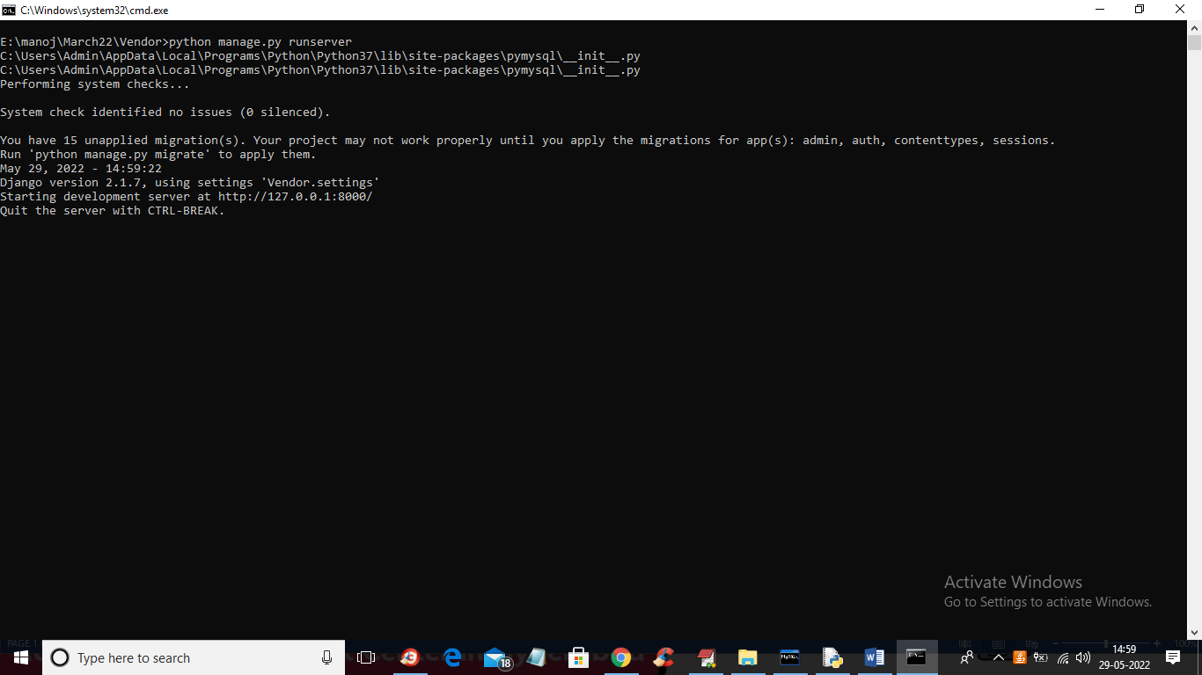

In above screen python DJANGO server started and now open browser and enter URL as <http://127.0.0.1:8000/index.html> and press enter key to get below page

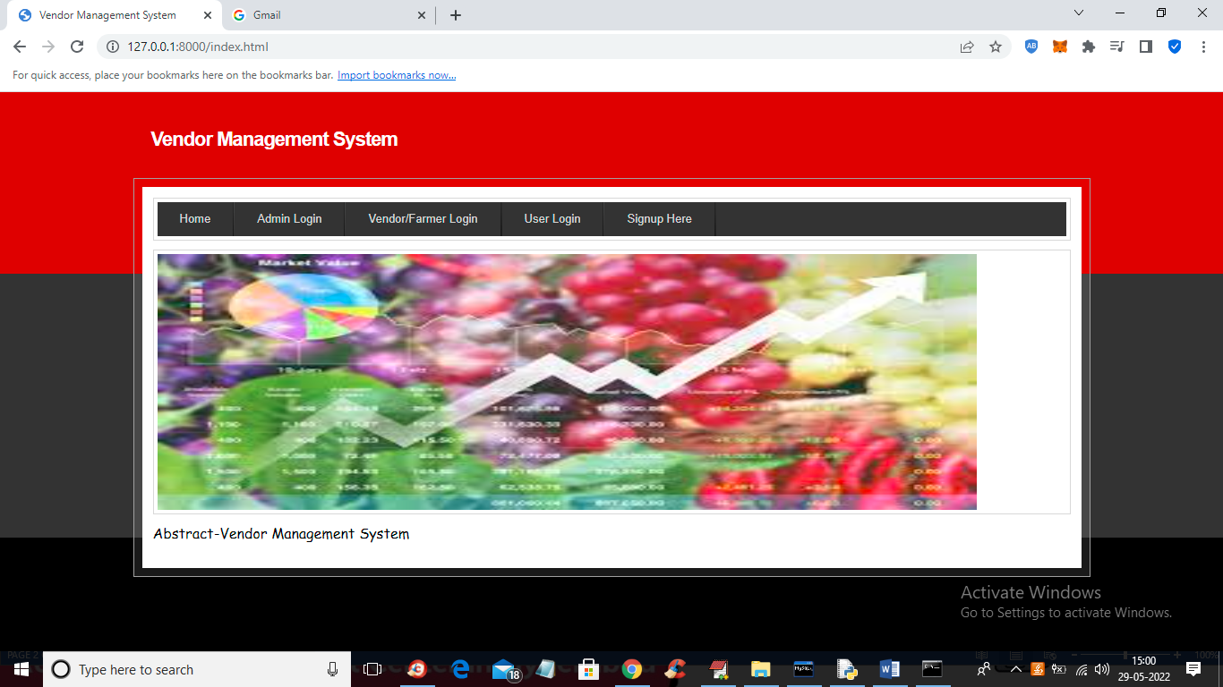

In above screen click on ‘Signup Here’ link to get below screen

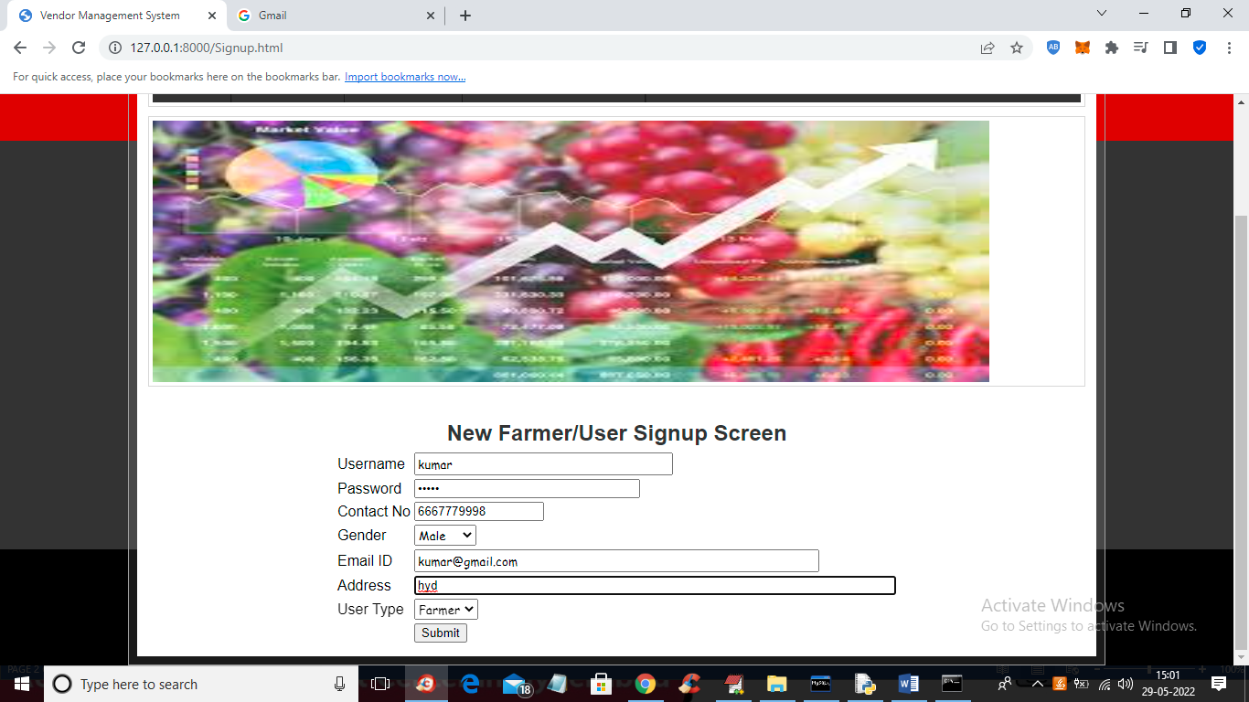

In above screen farmer is signup and press button to get below output

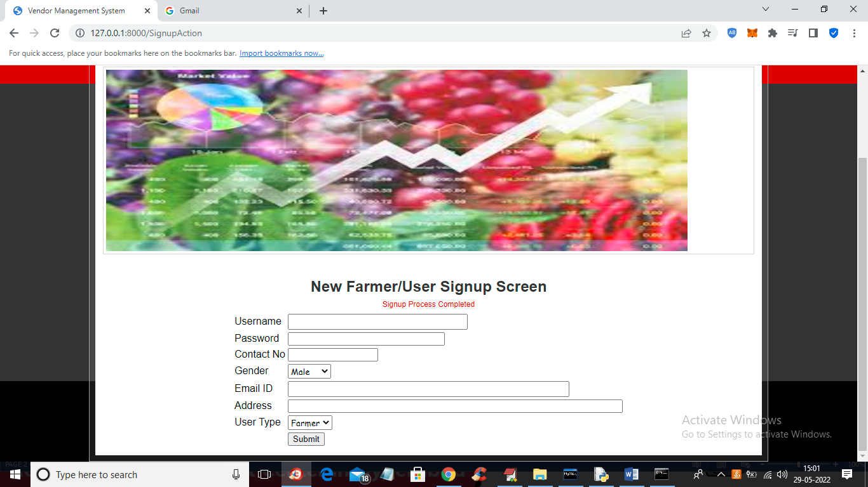

In above screen farmer signup process completed and similarly add user by selecting user type as ‘user’

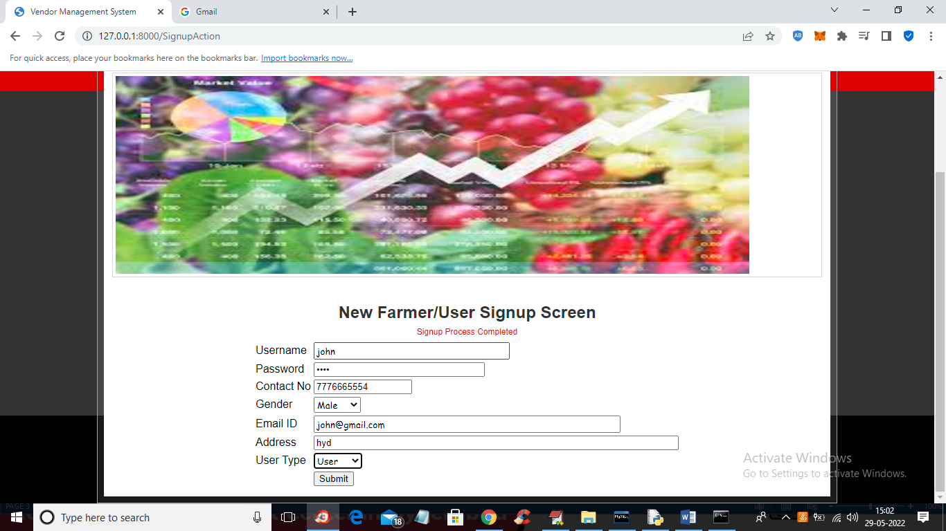

In above screen user is getting signup and now press button to get below output

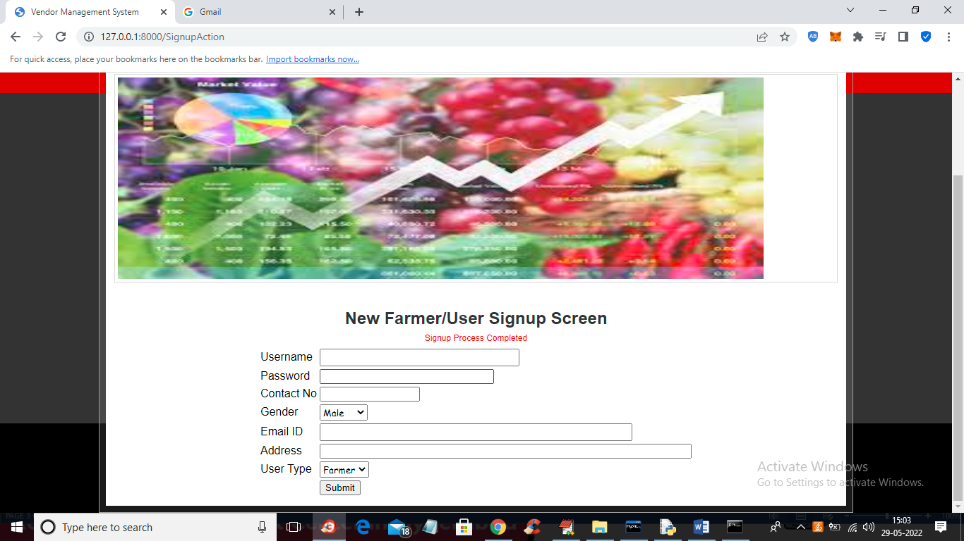

In above screen signup process completed and now click on ‘Vendor/Farmer Login’ link to get below screen

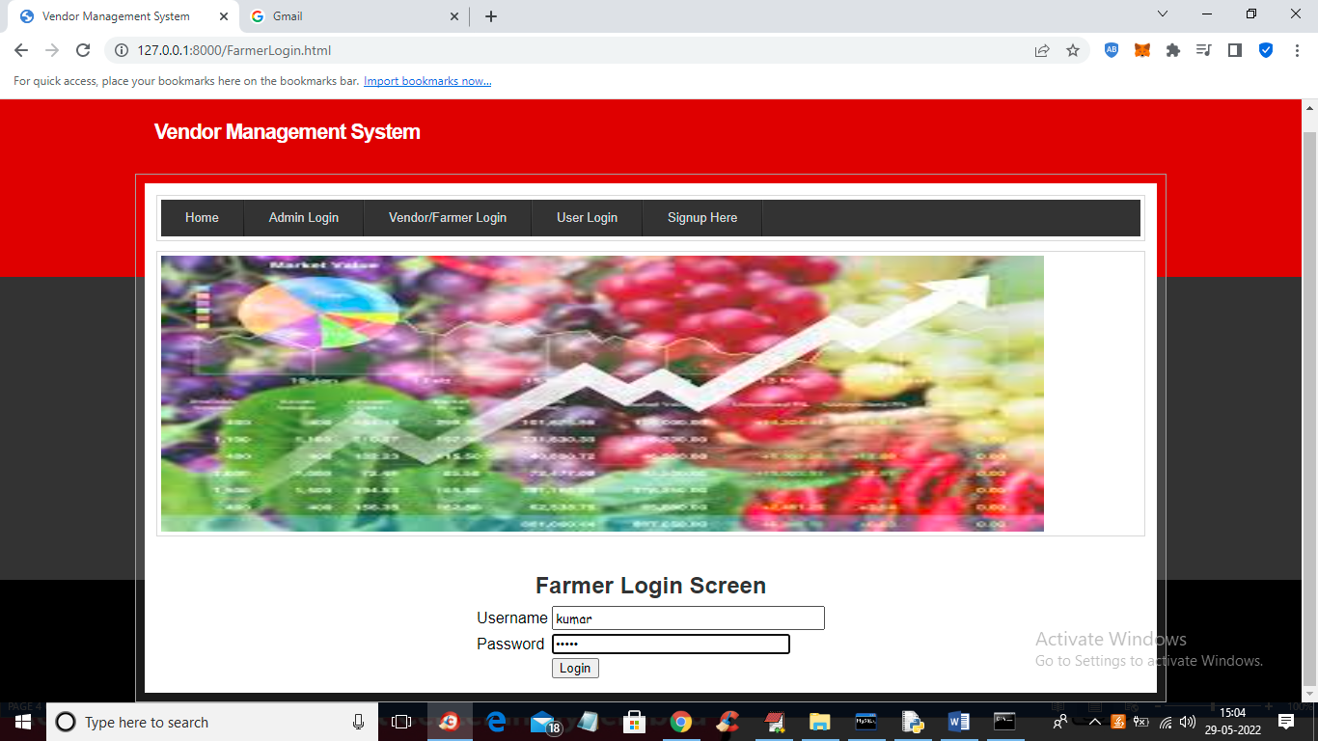

In above screen farmer is login and after login will get below screen

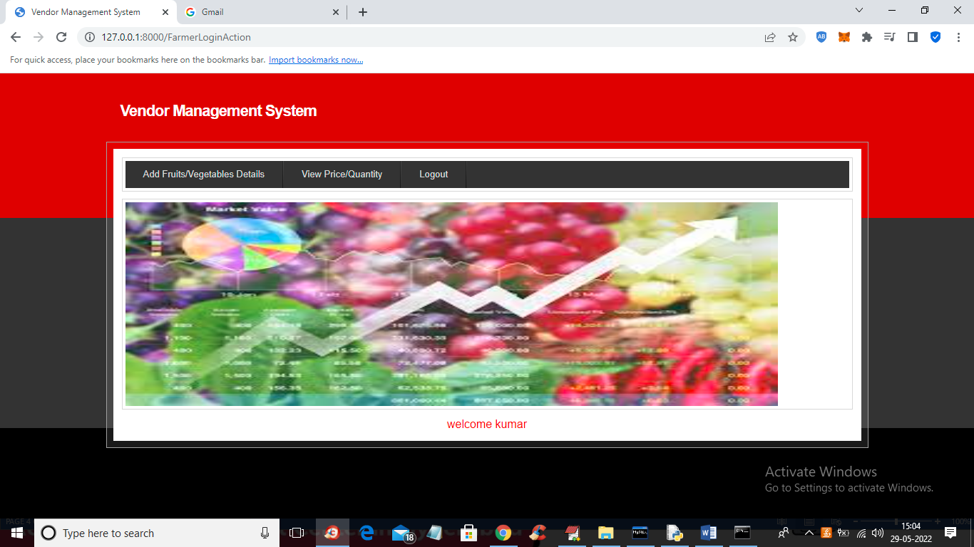

In above screen farmer can click on ‘Add Fruits/Vegetables Details’ link tot get below screen

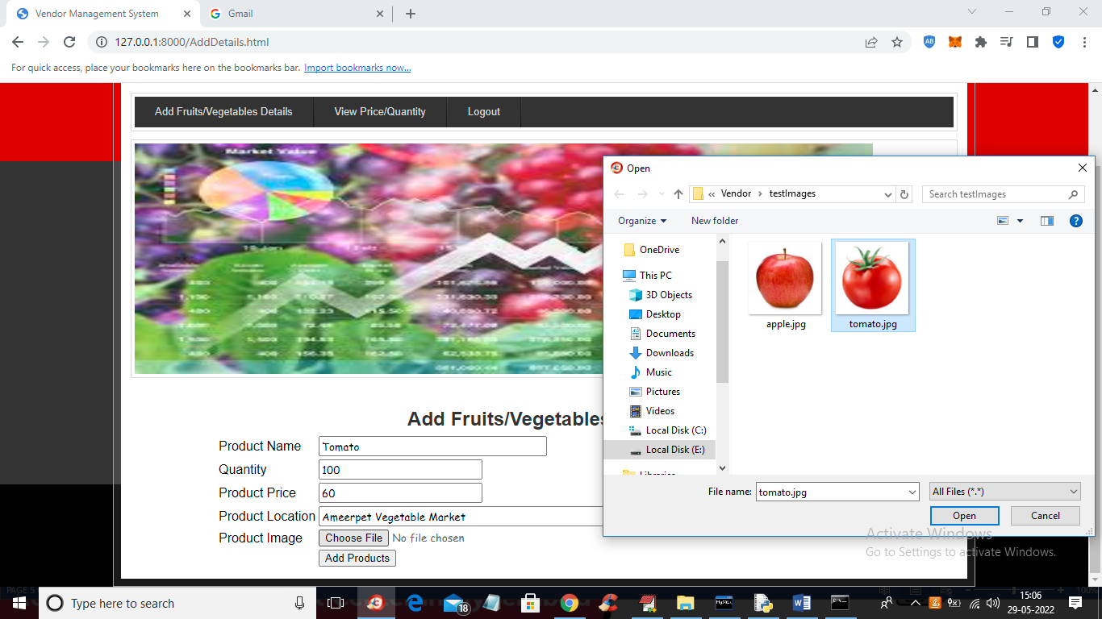

In above screen farmer can add product details and then upload image and then press button to get below output

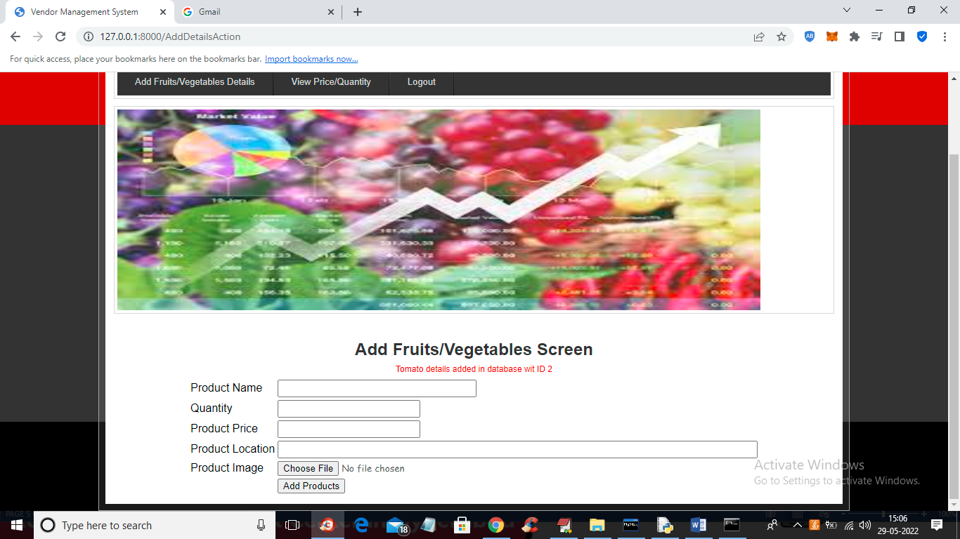

In above screen vegetable details added and now click on ‘View Price/Quantity’ link to view price details and update

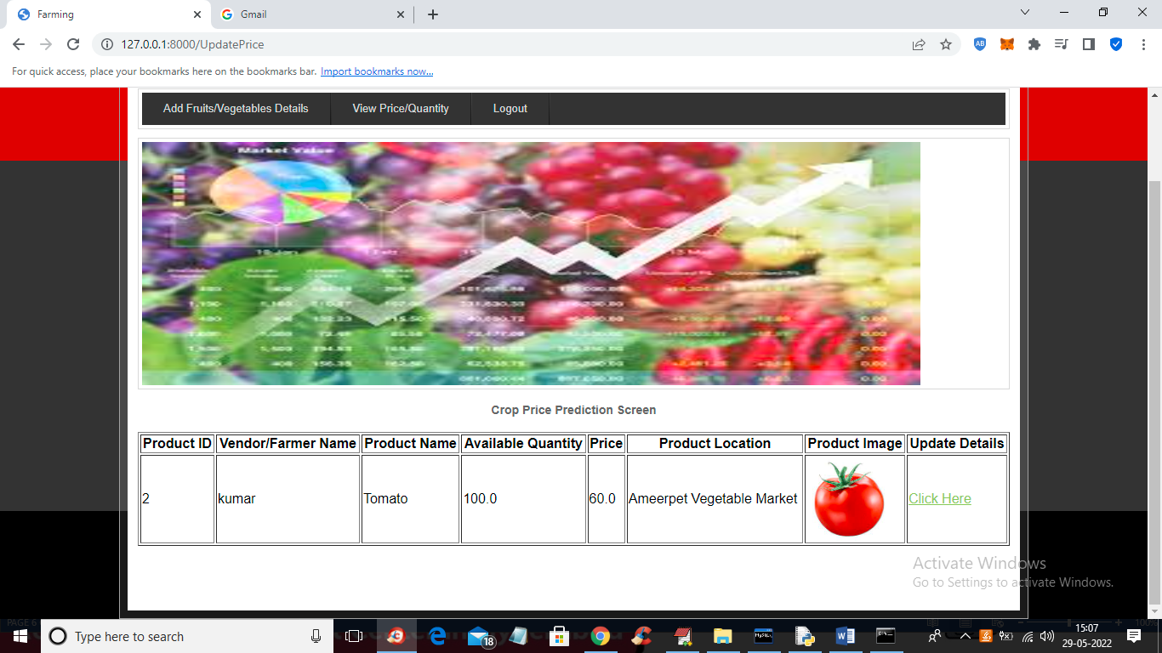

In above screen farmer can view all details and then click on ‘Click Here’ link to update quantity or price

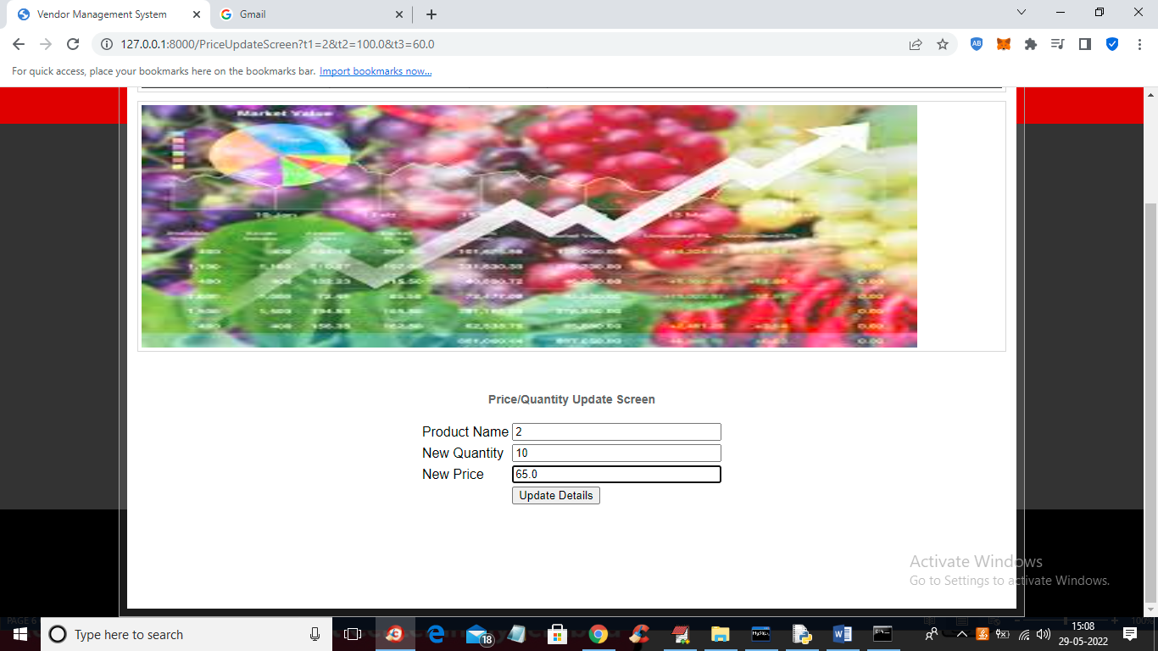

In above screen add new quantity and price details and press button to update it

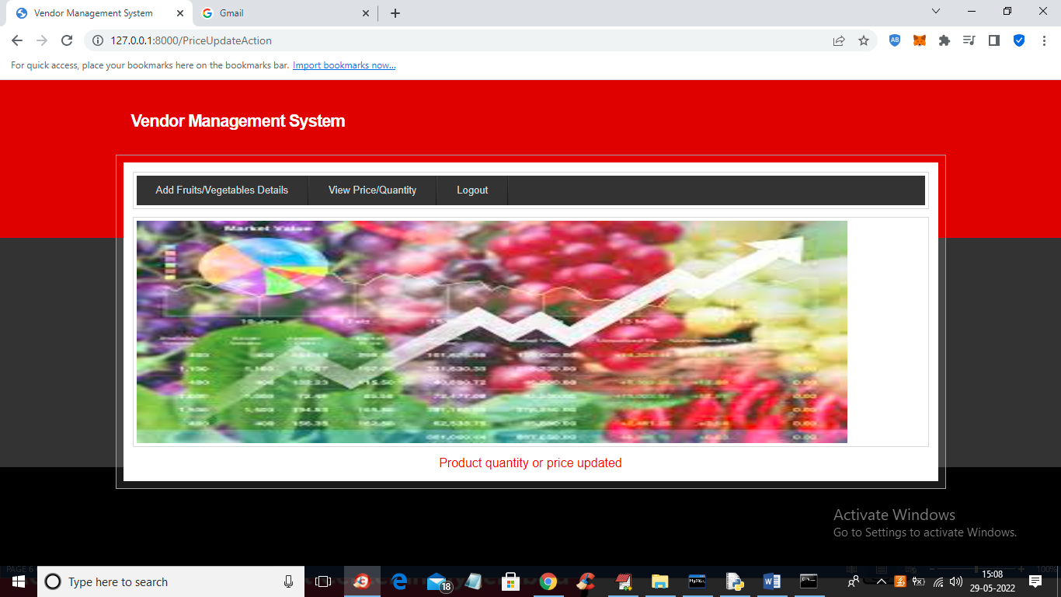

In above screen details updated and now logout and login as admin

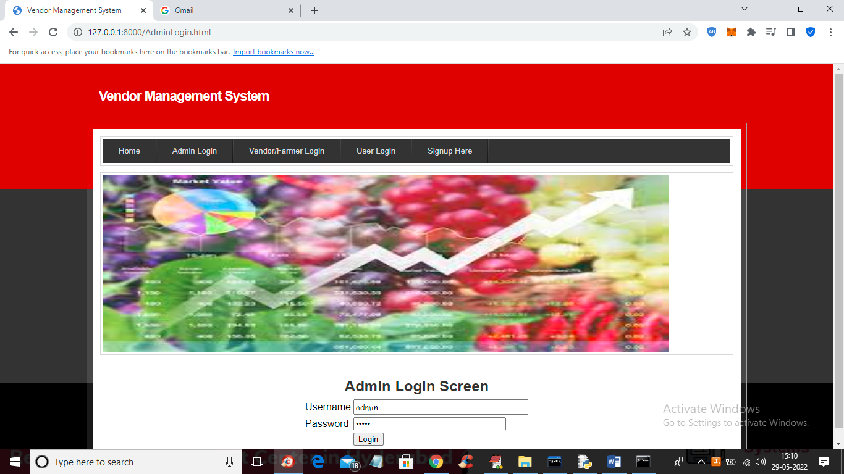

In above screen admin is login and after login will get below output

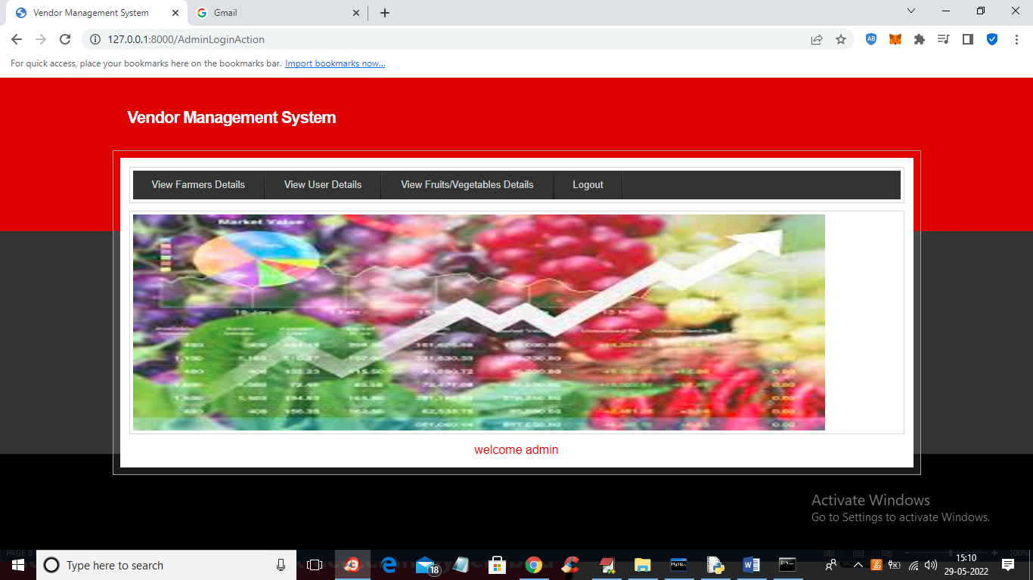

In above screen admin can click on ‘View Farmer Details’ to view all farmer details

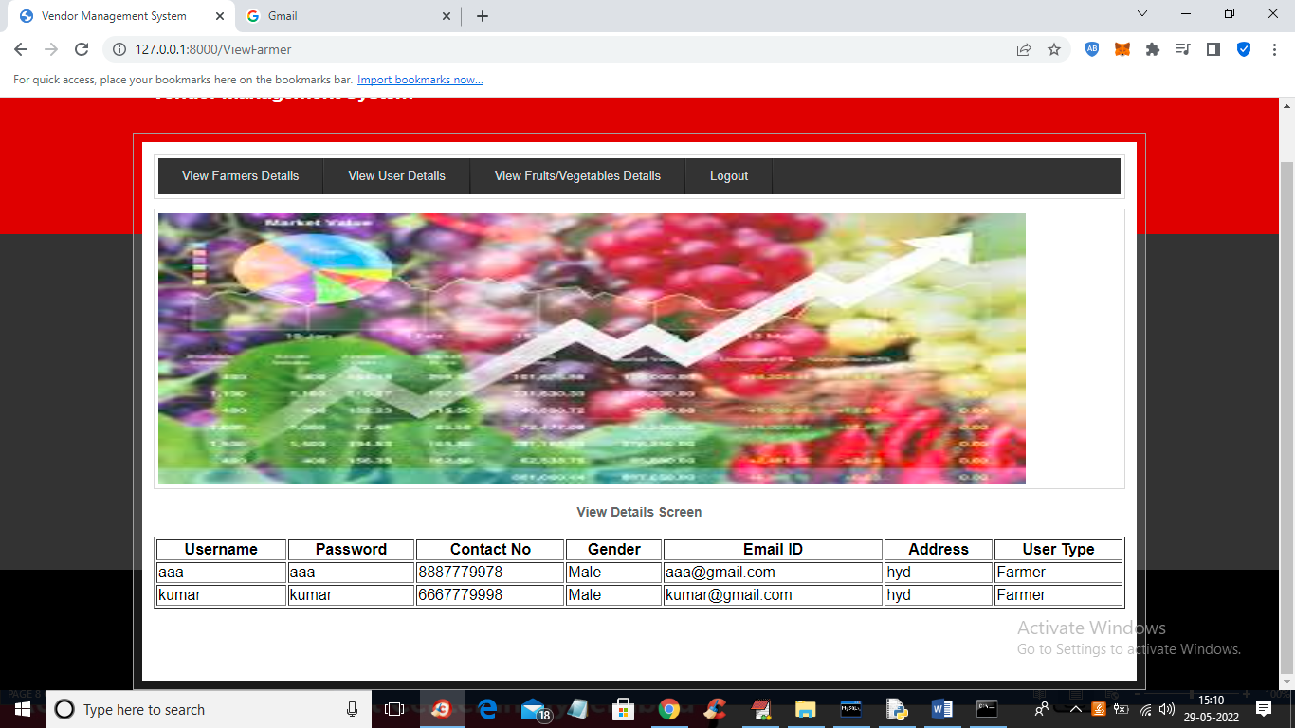

Similarly admin can click on ‘View User details’ link to view all users

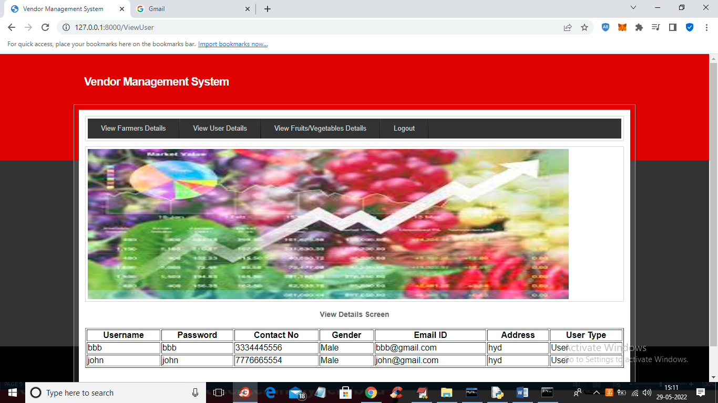

Similarly admin can click on ‘View Fruits/Vegetables Details’ link to view all details

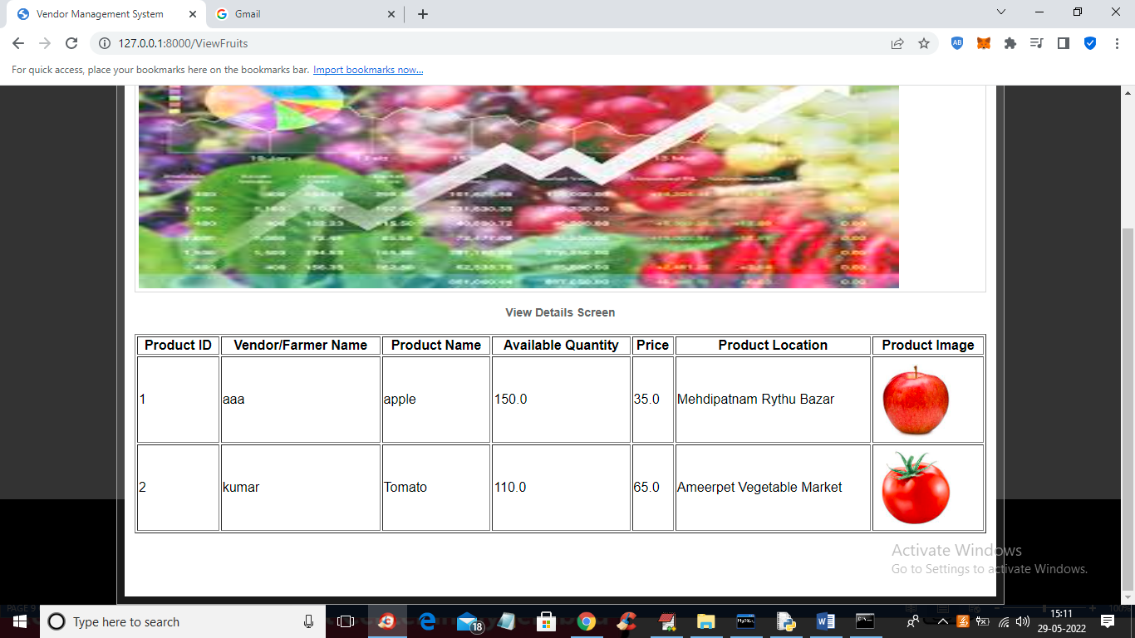

In above screen admin can view all product details and now logout and login as ‘User’ to view details

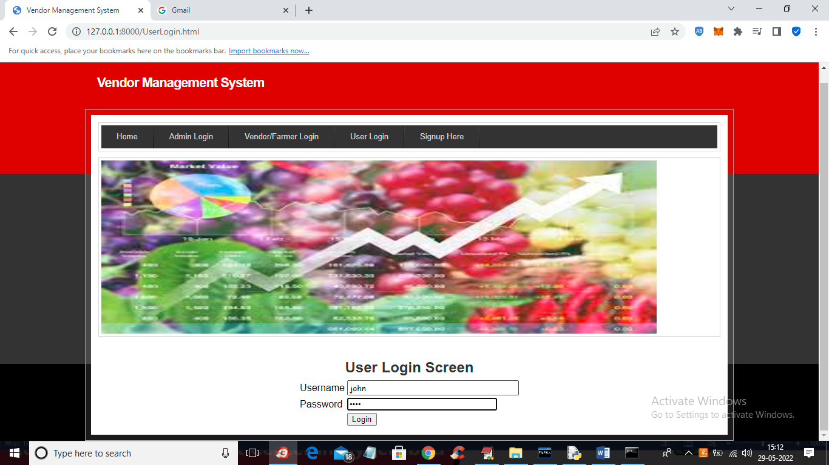

In above screen user is login and after login will get below screen

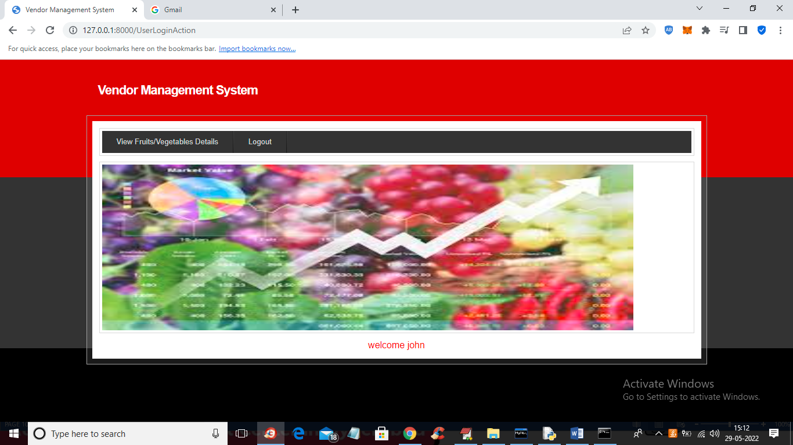

In above screen user can click on ‘View Fruits/Vegetables Details’ link to view all fruits/vegetables details with locations

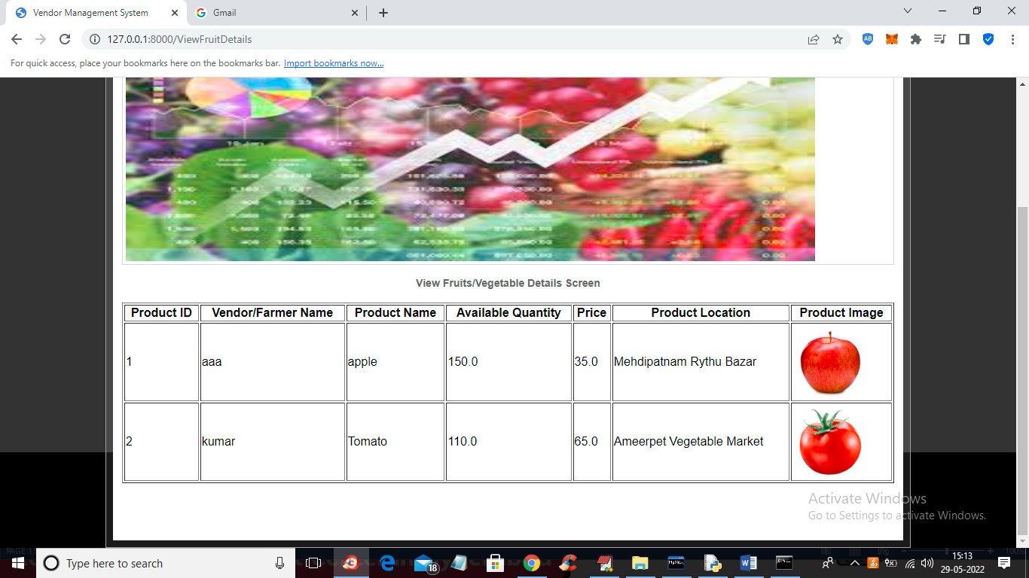

In above screen user can view fruits/vegetables details with locations

Similarly you can add and view any fruits or vegetables details